[GOOGLE EARTH ENGINE](EE01%20Earth%20Engine%20(EE).docx) [APPLICATION PROGRAMMING INTERFACE](EE05%20%20%20The%20EE%20API.docx) [CAPABILITIES](EE07%20%20%20%20%20%20API%20Capabilities.docx)

PROCESSING **DICTIONARY** [VARIABLES](EE13%20%20%20%20%20%20%20%20%20Variables.docx)

A dictionary is an EE variable object that represents a sequence of paired strings and values. Dictionaries can be processed by using operations of the types listed below, which vary according to the nature of that processing. Each operation name is linked to a separate page describing that operation.

**CREATING** DICTIONARIES ee.Dictionary

**EDITING** DICTIONARIES

BY **COMBINING** THEM dictionary.combine

BY **RESETTING** VALUES dictionary.set

**QUERYING** DICTIONARIES

FOR **KEYS** dictionary.keys

FOR **VALUES** dictionary.get dictionary.values dictionary.toArray

**COMPARING** DICTIONARIES

TO **DICTIONARIES** ee.Algorithms.IsEqual(dictionary)

FOR **DICTIONARY KEYS** dictionary.contains

**MEASURING** DICTIONARIES dictionary.size

**DOCUMENTING** DICTIONARIES dictionary.getInfo ee.Algorithms.Describe(dictionary)

dictionary.toString dictionary.serialize

**PRESENTING** DICTIONARIES

IN **PRINT** print(dictionary) console.log(dictionary)

alert(dictionary) confirm(dictionary)

[GOOGLE EARTH ENGINE](EE01%20Earth%20Engine%20(EE).docx) [APPLICATION PROGRAMMING INTERFACE](EE05%20%20%20The%20EE%20API.docx) [CAPABILITIES](EE07%20%20%20%20%20%20API%20Capabilities.docx)

**CREATING** DICTIONARY [VARIABLES](EE13%20%20%20%20%20%20%20%20%20Variables.docx)

ee.Dictionary creates a new dictionary presenting information on a specified (computed) object in JavaScript Object Notation (JSON) format.

newDictionary = ee.Dictionary ( oldObject )

The specified object

The new dictionary

var ThisDICTIONARY = ee.Dictionary( { town:'Llanfairpwllgwyngyllgogerychwyrndrobwllllantysiliogogogoch',

country:'Wales', lon:-4.2, lat:53.223, pop:3040 } );

var ThatDICTIONARY = ee.Dictionary( ee.Image('CGIAR/SRTM90_V4') );

print( ThisDICTIONARY, ThatDICTIONARY );

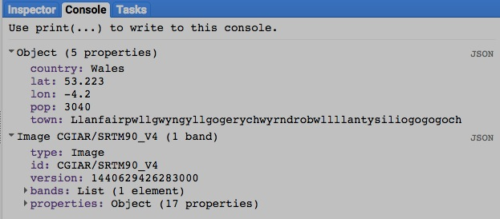

[GOOGLE EARTH ENGINE](EE01%20Earth%20Engine%20(EE).docx) [APPLICATION PROGRAMMING INTERFACE](EE05%20%20%20The%20EE%20API.docx) [CAPABILITIES](EE07%20%20%20%20%20%20API%20Capabilities.docx)

**EDITING** DICTIONARY [VARIABLES](EE13%20%20%20%20%20%20%20%20%20Variables.docx) BY **COMBINING** THEM

dictionary.combine creates new dictionary by combining two specified dictionaries.

newDictionary = firstDictionary.combine ( secondDictionary, *favorTheFirst* )

A Boolean set to True (only) if values for duplicate keys are

to be drawn from the first dictionary specified. Default: True

The second specified dictionary

The first specified dictionary

The new dictionary

var ElectedLASTYEAR = ee.Dictionary( { president:'You', secretary:'Me' } );

var ElectedTHISYEAR = ee.Dictionary( { secretary:'Her', treasurer:'Me' } );

var ServingNEXTYEAR = ElectedLASTYEAR.combine( ElectedTHISYEAR, true );

print( ElectedLASTYEAR, ElectedTHISYEAR, ServingNEXTYEAR );

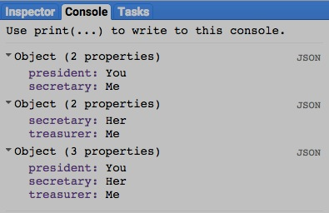

[GOOGLE EARTH ENGINE](EE01%20Earth%20Engine%20(EE).docx) [APPLICATION PROGRAMMING INTERFACE](EE05%20%20%20The%20EE%20API.docx) [CAPABILITIES](EE07%20%20%20%20%20%20API%20Capabilities.docx)

**EDITING** DICTIONARY [VARIABLES](EE13%20%20%20%20%20%20%20%20%20Variables.docx) BY **RESETTING** VALUES

dictionary.set creates new dictionary by replicating a specified dictionary after setting or resetting a specified key to a specified value.

newDictionary = oldDictionary.set ( key, associatedValue )

The associated value

The specified key

The specified dictionary

The new dictionary

var OldDICTIONARY = ee.Dictionary( { town:'Llanfairpwllgwyngyllgogerychwyrndrobwllllantysiliogogogoch',

country:'Wales', lon:-4.2, lat:53.223, pop:3040 } );

var NewDICTIONARY = OldDICTIONARY.set('pop', 3041 );

print( OldDICTIONARY, NewDICTIONARY );

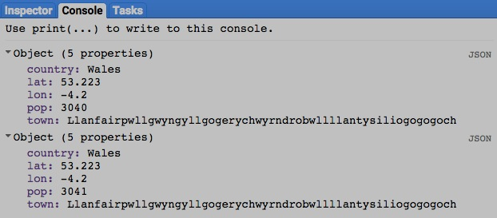

[GOOGLE EARTH ENGINE](EE01%20Earth%20Engine%20(EE).docx) [APPLICATION PROGRAMMING INTERFACE](EE05%20%20%20The%20EE%20API.docx) [CAPABILITIES](EE07%20%20%20%20%20%20API%20Capabilities.docx)

**QUERYING** DICTIONARY [VARIABLES](EE13%20%20%20%20%20%20%20%20%20Variables.docx) FOR **KEYS**

dictionary.keys creates a new list containing the keys from a specified dictionary, sorted in ascending order.

newList = oldDictionary.keys ( )

The new list

The specified dictionary

var OldDICTIONARY = ee.Dictionary( { town:'Llanfairpwllgwyngyllgogerychwyrndrobwllllantysiliogogogoch',

country:'Wales', lon:-4.2, lat:53.223, pop:3040 } );

var NewLIST = OldDICTIONARY.keys( );

print( OldDICTIONARY, NewLIST );

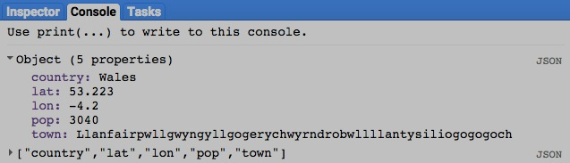

[GOOGLE EARTH ENGINE](EE01%20Earth%20Engine%20(EE).docx) [APPLICATION PROGRAMMING INTERFACE](EE05%20%20%20The%20EE%20API.docx) [CAPABILITIES](EE07%20%20%20%20%20%20API%20Capabilities.docx)

**QUERYING** DICTIONARY [VARIABLES](EE13%20%20%20%20%20%20%20%20%20Variables.docx) FOR **VALUES**

dictionary.get creates a new object replicating the value associated with a specified key in a specified dictionary.

newObject = oldDictionary.get ( key )

The specified dictionary

The specified key, given as a string

The new object

var OldDICTIONARY = ee.Dictionary( { town:'Llanfairpwllgwyngyllgogerychwyrndrobwllllantysiliogogogoch',

country:'Wales', lon:-4.2, lat:53.223, pop:3040 } );

var NewVALUE = OldDICTIONARY.get( 'lat' );

print( OldDICTIONARY, NewVALUE );

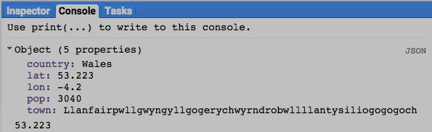

[GOOGLE EARTH ENGINE](EE01%20Earth%20Engine%20(EE).docx) [APPLICATION PROGRAMMING INTERFACE](EE05%20%20%20The%20EE%20API.docx) [CAPABILITIES](EE07%20%20%20%20%20%20API%20Capabilities.docx)

**QUERYING** DICTIONARY [VARIABLES](EE13%20%20%20%20%20%20%20%20%20Variables.docx) FOR **VALUES**

dictionary.values creates a new list containing the values from a specified dictionary, sorted in the ascending order of their associated keys.

newList = oldDictionary.values ( *selectedKeys* )

A list of keys identifying the items to be considered. Default: All items

The specified dictionary

The new list

var OldDICTIONARY = ee.Dictionary( { town:'Llanfairpwllgwyngyllgogerychwyrndrobwllllantysiliogogogoch',

country:'Wales', lon:-4.2, lat:53.223, pop:3040 } );

var NewLIST = OldDICTIONARY.values( [ 'lon', 'lat', 'pop' ] );

print( OldDICTIONARY, NewLIST );

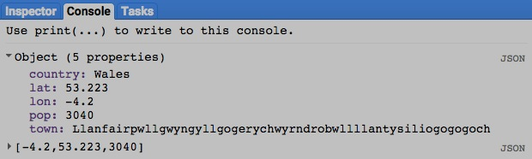

[GOOGLE EARTH ENGINE](EE01%20Earth%20Engine%20(EE).docx) [APPLICATION PROGRAMMING INTERFACE](EE05%20%20%20The%20EE%20API.docx) [CAPABILITIES](EE07%20%20%20%20%20%20API%20Capabilities.docx)

**QUERYING** DICTIONARY [VARIABLES](EE13%20%20%20%20%20%20%20%20%20Variables.docx) FOR **VALUES**

dictionary.toArray creates a new array containing the values associated with specified keys of a specified dictionary, sorted in the ascending order of those keys.

newArray = oldDictionary.toArray ( *selectedKeys*, *axis* )

The new array

The specified dictionary

The index of the array axis to which values are to be written, given as an integer. Default: 0

The keys for whatever dictionary items are to be considered, given as a list of strings. Default: All items

var OldDICTIONARY = ee.Dictionary( { town:'Llanfairpwllgwyngyllgogerychwyrndrobwllllantysiliogogogoch',

country:'Wales', lon:-4.2, lat:53.223, pop:3040 } );

var NewARRAY = OldDICTIONARY.toArray( ['lon','lat','pop']);

print( OldDICTIONARY, NewARRAY );

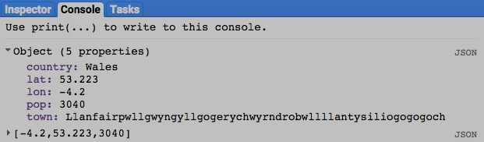

[GOOGLE EARTH ENGINE](EE01%20Earth%20Engine%20(EE).docx) [APPLICATION PROGRAMMING INTERFACE](EE05%20%20%20The%20EE%20API.docx) [CAPABILITIES](EE07%20%20%20%20%20%20API%20Capabilities.docx)

**COMPARING** DICTIONARY [VARIABLES](EE13%20%20%20%20%20%20%20%20%20Variables.docx) TO **DICTIONARIES**

ee.Algorithms.IsEqual creates a new Boolean set to True (only) if the first of two specified dictionaries is identical to the second in both structure and content.

newBoolean = ee.Algorithms.IsEqual ( 1stDictionary, 2ndDictionary )

The second specified dictionary

The first specified dictionary

The new Boolean

var FirstDICTIONARY = ee.Dictionary( { president:'You', secretary:'Me' } );

var SecondDICTIONARY = ee.Dictionary( { president:'You', secretary:'Her' } );

var TrueOrFalse = ee.Algorithms.IsEqual( FirstDICTIONARY, SecondDICTIONARY );

print( FirstDICTIONARY, SecondDICTIONARY );

print( 'Is it true or false that those two dictionaries are equal?' );

print( TrueOrFalse );

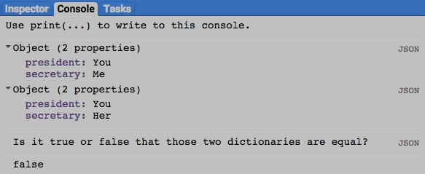

[GOOGLE EARTH ENGINE](EE01%20Earth%20Engine%20(EE).docx) [APPLICATION PROGRAMMING INTERFACE](EE05%20%20%20The%20EE%20API.docx) [CAPABILITIES](EE07%20%20%20%20%20%20API%20Capabilities.docx)

**COMPARING** DICTIONARY [VARIABLES](EE13%20%20%20%20%20%20%20%20%20Variables.docx) TO **DICTIONARY KEYS**

dictionary.contains creates a Boolean set to true (only) if a specified dictionary contains a specified key. Otherwise, it is set to false.

newBoolean = oldDictionary.contains ( *key* )

The specified key, given as a string. Default: null

The new Boolean

The specified dictionary

var TheDICTIONARY = ee.Dictionary( { town:'Llanfairpwllgwyngyllgogerychwyrndrobwllllantysiliogogogoch',

country:'Wales', lon:-4.2, lat:53.223, pop:3040 } );

var TrueOrFalse = TheDICTIONARY.contains( 'country' );

print( TheDICTIONARY );

print( 'Is it true or false that the dictionary above contains a ‘country’ key?' );

print( TrueOrFalse );

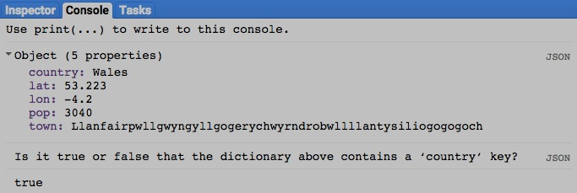

[GOOGLE EARTH ENGINE](EE01%20Earth%20Engine%20(EE).docx) [APPLICATION PROGRAMMING INTERFACE](EE05%20%20%20The%20EE%20API.docx) [CAPABILITIES](EE07%20%20%20%20%20%20API%20Capabilities.docx)

**MEASURING** DICTIONARY [VARIABLES](EE13%20%20%20%20%20%20%20%20%20Variables.docx)

dictionary.size creates a new integer indicating the number of items in a specified dictionary.

newInteger = oldDictionary.size ()

The new integer

The specified dictionary

var TheDICTIONARY = ee.Dictionary( { town:'Llanfairpwllgwyngyllgogerychwyrndrobwllllantysiliogogogoch',

country:'Wales', lon:-4.2, lat:53.223, pop:3040 } );

var TheNUMBER = TheDICTIONARY.size( );

print( TheDICTIONARY );

print( 'The number of items in the dictionary above is as follows.' );

print( TheNUMBER );

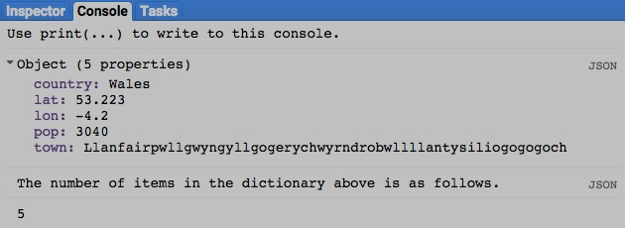

[GOOGLE EARTH ENGINE](EE01%20Earth%20Engine%20(EE).docx) [APPLICATION PROGRAMMING INTERFACE](EE05%20%20%20The%20EE%20API.docx) [CAPABILITIES](EE07%20%20%20%20%20%20API%20Capabilities.docx)

**DOCUMENTING** DICTIONARY [VARIABLES](EE13%20%20%20%20%20%20%20%20%20Variables.docx)

ee.Algorithms.Describe and dictionary.getInfo

each creates a JSON-compatible text object representing a specified dictionary.

newObject = ee.Algorithms.Describe( oldDictionary )

and oldDictionary.getInfo( )

The new object

The specified dictionary

var OldDICTIONARY = ee.Dictionary( { who:'You', what:'Are', when:'Now', where:'Here', why:'To find out' } );

print( 'New string from the original dictionary', OldDICTIONARY );

print( 'New string from ee.Algorithms.Describe', ee.Algorithms.Describe( OldDICTIONARY ) );

print( 'New string from dictionary.getInfo( )', OldDICTIONARY.getInfo( ) );

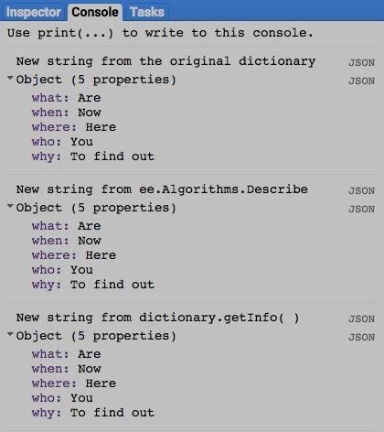

[GOOGLE EARTH ENGINE](EE01%20Earth%20Engine%20(EE).docx) [APPLICATION PROGRAMMING INTERFACE](EE05%20%20%20The%20EE%20API.docx) [CAPABILITIES](EE07%20%20%20%20%20%20API%20Capabilities.docx)

**DOCUMENTING** DICTIONARY [VARIABLES](EE13%20%20%20%20%20%20%20%20%20Variables.docx)

dictionary.toString and .serialize each creates a new string presenting information on a specified dictionary.

newString = oldDictionary.toString ( )

and oldDictionary.serialize( )

The specified dictionary

The new string

var OldDICTIONARY = ee.Dictionary( { who:'You', what:'Are', when:'Now', where:'Here', why:'To find out' } );

print( 'New string from the original dictionary', OldDICTIONARY );

print( 'New string from dictionary.toString( )', OldDICTIONARY.toString( ) );

print( 'New string from dictionary.serialize( )', OldDICTIONARY.serialize( ) );

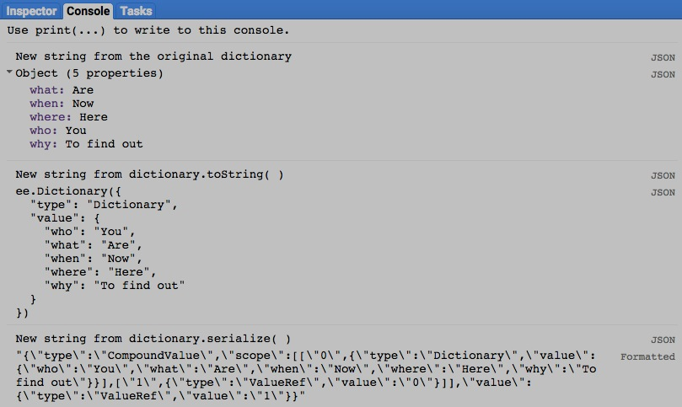

[GOOGLE EARTH ENGINE](EE01%20Earth%20Engine%20(EE).docx) [APPLICATION PROGRAMMING INTERFACE](EE05%20%20%20The%20EE%20API.docx) [CAPABILITIES](EE07%20%20%20%20%20%20API%20Capabilities.docx)

**MEASURING** DICTIONARY [VARIABLES](EE13%20%20%20%20%20%20%20%20%20Variables.docx) IN **PRINT**

print ( dictionary ) and console.log ( dictionary ) present JSON-formatted text renditions of a specified dictionary in the console.

print( oldDictionary ) or console.log( oldDictionary )

The specified dictionary

var TheDICTIONARY = ee.Dictionary( { who:'You', what:'Are', when:'Now', where:'Here', why:'To find out' } );

print( TheDICTIONARY );

console.log( TheDICTIONARY );

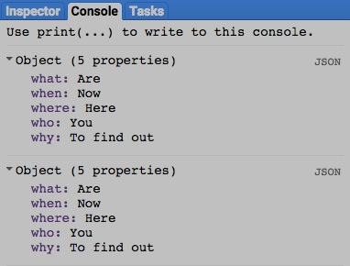

[GOOGLE EARTH ENGINE](EE01%20Earth%20Engine%20(EE).docx) [APPLICATION PROGRAMMING INTERFACE](EE05%20%20%20The%20EE%20API.docx) [OPERATIONS](EE07%20%20%20%20%20%20API%20Capabilities.docx) **PRESENTING** DICTIONARIESAS [VARIABLES](EE13%20%20%20%20%20%20%20%20%20Variables.docx)

alert ( dictionary ) and confirm( dictionary ) present JSON-formatted text renditions of a specified dictionary in a pop-up message box.

alert( oldDictionary ) or confirm( oldDictionary )

The specified dictionary

var TheDICTIONARY = ee.Dictionary( { who:'You', what:'Are', when:'Now', where:'Here', why:'To find out' } );

alert( TheDICTIONARY );

confirm( TheDICTIONARY );

